Star Schema Assignment

University Scenario

6/11/2015

CPUT

Shannon Scholtz

Student Number: 212125583

**Database Fields of University Scenario Star Schema:**

**FACT Table: Fact University**

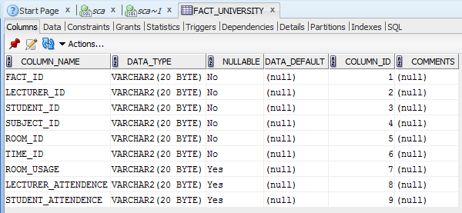

**Lecturer Table: Lecturer**

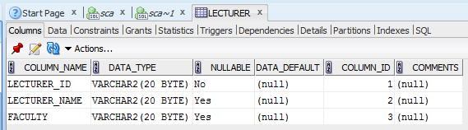

**Room Table: Room**

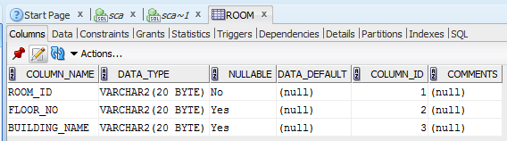

**Student table: Student**

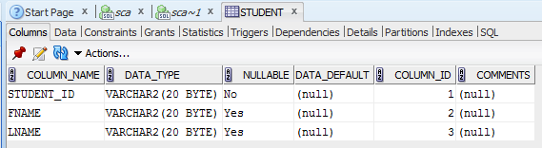

**Subject Table: Subject**

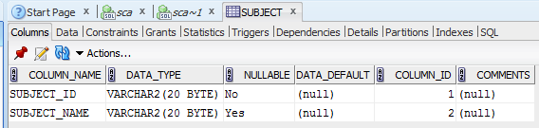

**Time Table: Time_tab**

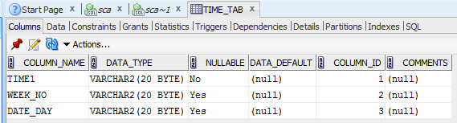

**Test Data:**

**Fact_University**

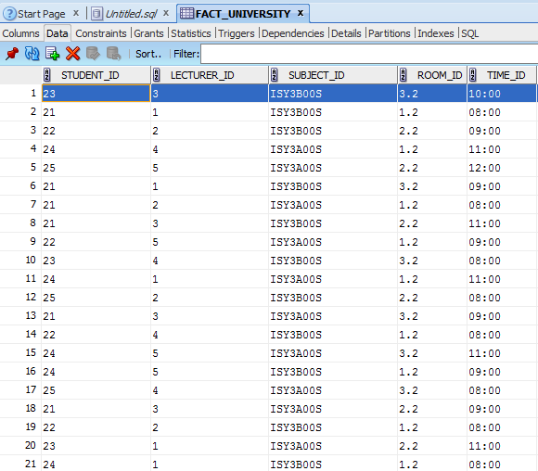

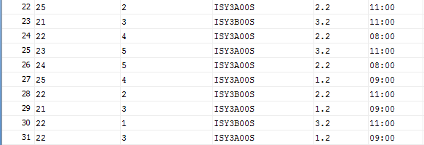

**Lecturer Table: Lecturer**

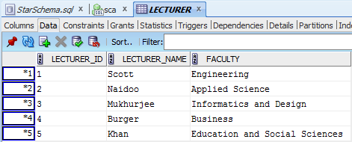

**Room Table: Room**

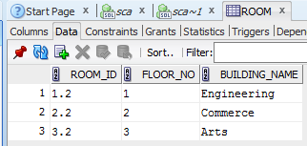

**Student table: Student**

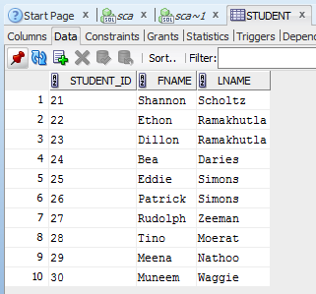

**Subject Table: Subject**

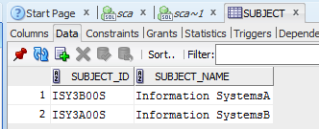

**Time Table: Time_tab**

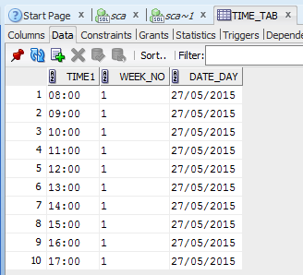

**Star Schema:**

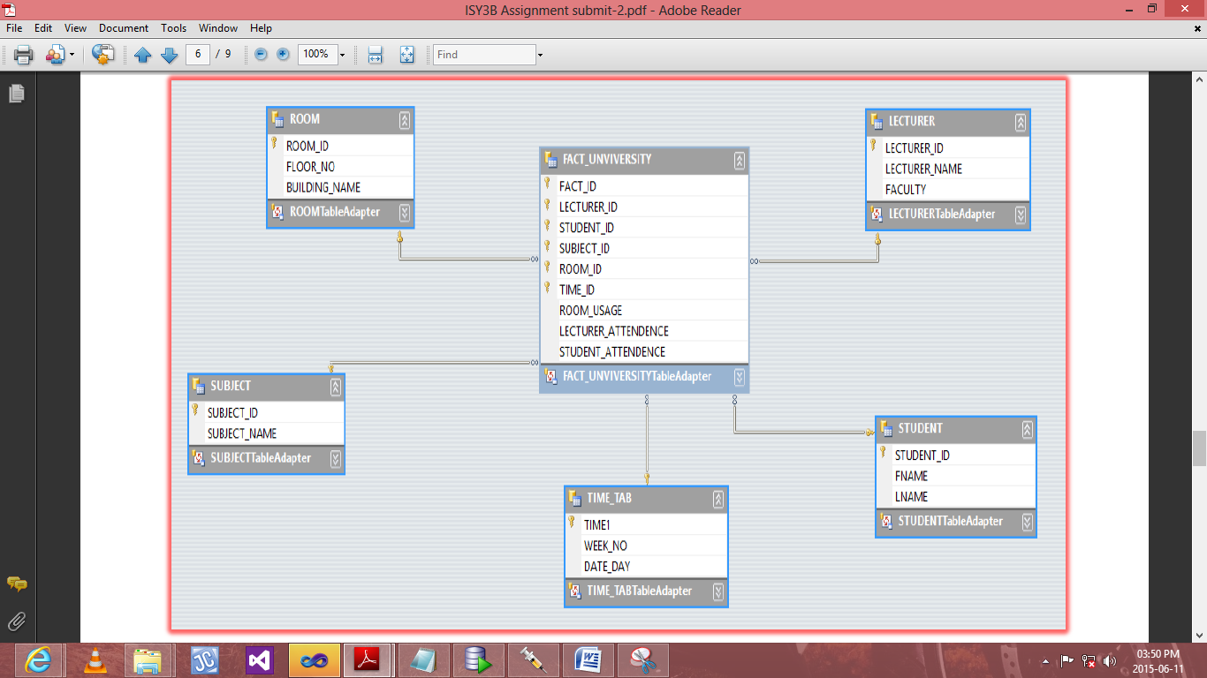

**Reports:**

**Percentage of room usage**

**Room ID: 1.2**

**Lecturer ID: 1**

**Lecturer ID: 4**

**Lecturer ID: 2**

**Lecturer ID: 5**

**Lecturer ID: 1**

**Lecturer ID: 4**

**Lecturer ID: 5**

**Lecturer ID: 2**

**Lecturer ID: 1**

**Lecturer ID: 4**

**Lecturer ID: 3**

**Lecturer ID: 3**

**Percentage:38%**

**Room ID: 2.2**

**Lecturer ID: 2**

**Lecturer ID: 5**

**Lecturer ID: 3**

**Lecturer ID: 2**

**Lecturer ID: 3**

**Lecturer ID: 1**

**Lecturer ID: 2**

**Lecturer ID: 4**

**Lecturer ID: 5**

**Lecturer ID: 2**

**Percentage: 32%**

**Room ID: 3.2**

**Lecturer ID: 3**

**Lecturer ID: 1**

**Lecturer ID: 4**

**Lecturer ID: 3**

**Lecturer ID: 5**

**Lecturer ID: 4**

**Lecturer ID: 3**

**Lecturer ID: 5**

**Lecturer ID: 1**

**Percentage: 29%**

**Total Number Of Classes Timetabled For The Semester**

**ISY3A00S =17**

**ISY3B00S =14**

**Percentage Of Attendance Of Students**

**ISY3A00S= 54%**

**ISY3B00S= 45%**

**Percentage Of Attendance Of Lecturers**

**ISY3A00S=54%**

**ISY3B00S=45%**

**Total Number Of Times The Room Has Been Used:**

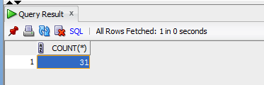

**Students And Lectures Make Use of Room 3.2**

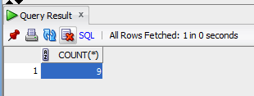

**Students And Lectures Make Use Room 1.2**

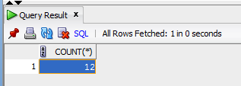

**Students And Lectures Make Use Room 2.2**

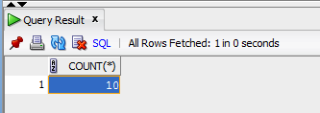

**Number Of Times All Students Attended ISY3B00S Over The Semester**

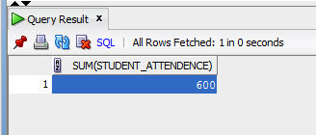

**Number Of Times All Students Attended ISY3A00S Over The Semester**

